Maddy Newquist
INFO 677
Book Talk #2

Pet by Akwaeke Emezi

Audience: Reluctant Readers in late MS/early HS
Relevant development Assets: Support (Family Support, Positive Family Communication, Caring Neighborhood); Boundaries & Expectations (Neighborhood Boundaries, Adult Role Models); Positive Values (all except Restraint); Social Competencies (Interpersonal Competence, Peaceful Conflict Resolution)
Book’s official tagline: Pet is here to hunt a monster. Are you brave enough to look?
For fans of: The 100, Shadowhunters (TV); for dormant/developing readers: titles on bookmark; for more advanced readers: author Jeff VanderMeer, Sister Mine by Nalo Hopkinson
Publisher’s website: https://www.makemeaworld.com/books/586483/pet-by-akwaeke-emezi/

[SCRIPT]
Pet by Akwaeke Emezi.

You are Jam. You are 16 years old and you live in Lucille, a city saved by angels. Angels who drove the monsters out, the monsters who kept children in cages and shot children in the street and watched children get shot by other children and did nothing to stop any of it. Lucille has been free of monsters for many, many years—so many years, in fact, that any information about how to identify monsters is now kept in the back of a dusty, old archive.

You are Jam. Your father is a paramedic and your mother is an artist. Your house speaks to you, and tonight, it doesn’t like your mother’s new painting. So you sneak into your mother’s studio to see her work. But your mother has painted wings of razors onto her creature made of smoke and ink and color, and when you fall onto the canvas, you add some color of your own. You add a deep, dark red, and the creature your mother has created begins to crawl out of the painting.

You are Jam and this is Pet. Pet hunts monsters. There is a monster left in Lucille, and you are the only human who is willing to believe that it is here.

You are Jam. Your best friend is Redemption and there is a monster in his house. Pet is here to hunt it and now, so are you. Do not be afraid… of Pet by Akwaeke Emezi.

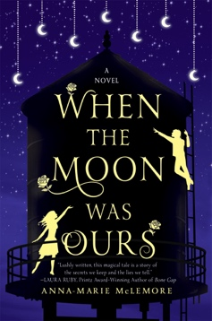
IF YOU LOVED

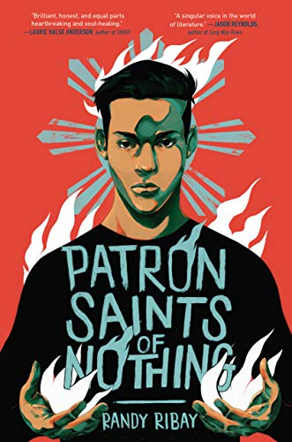
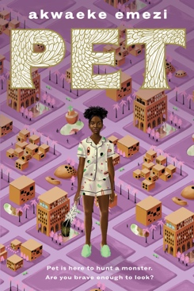
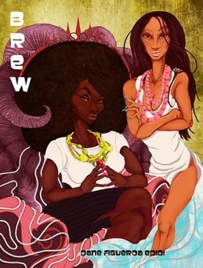
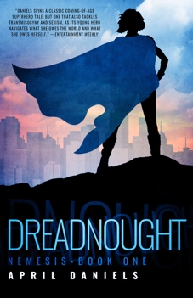
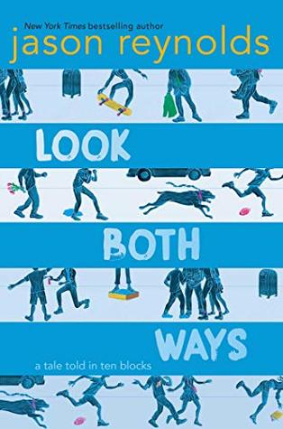
When the Moon was Ours
by Anna-Marie McLemore

Miel grows roses out of her wrists and Sam paints moons into the sky. But when four witches target the two best friends, more is at stake than just their personal magic.
Patron Saints of Nothing
by Randy Ribay

After his cousin is murdered and his family refuses to discuss it, Jay travels to the Philippines to find out the truth and his own role in it.
YOU MIGHT LIKE…

Brew by Dane Figueroa Edidi

A trans teen witch and her powerful mom get caught up in a conspiracy theory as old enemies emerge to take vengeance.
Dreadnought by April Daniels

A closeted trans girl inherits unexpected superpowers—and must navigate a world that thinks her new body is unwanted.
Look Both Ways
by Jason Reynolds

What happens when 10 people are so caught up in their own lives that they miss a school bus falling from the sky?
IF YOU LOVED

When the Moon was Ours
by Anna-Marie McLemore

Miel grows roses out of her wrists and Sam paints moons into the sky. But when four witches target the two best friends, more is at stake than just their personal magic.

YOU MIGHT LIKE…

Patron Saints of Nothing
by Randy Ribay

After his cousin is murdered and his family refuses to discuss it, Jay travels to the Philippines to find out the truth and his own role in it.
Look Both Ways
by Jason Reynolds

What happens when 10 people are so caught up in their own lives that they miss a school bus falling from the sky?

Brew by Dane Figueroa Edidi

A trans teen witch and her powerful mom get caught up in a conspiracy theory as old enemies emerge to take vengeance.
Dreadnought by April Daniels

A closeted trans girl inherits unexpected superpowers—and must navigate a world that thinks her new body is unwanted.

